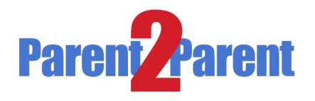
A parental communication initiative sponsored by East Texas GEAR UP and its school district partners. Parents are recruited and trained to go out in the community with the goal of educating more parents about college and careers.
Parents serve as the grass-roots organizers, trainers and distributors of educational information and resources. Recruitment: Each district enlisted its most dedicated parents to take part of this unique concept. Currently, the districts have thirty-four (34) P2P volunteers combined.

It is dream of every parent that their child reach their educational and personal potential—according abilities. As adults it is our responsibility to help inspire our youth by Opening Doors that create an opportunity for them to explore a positive future.
Parent2Parent is a parental communication initiative sponsored by the East Texas GEAR UP for Success Partnership and Central ISD, Hudson ISD, Lufkin ISD, Nacogdoches ISD, and Woden ISD.
The Parent2Parent program is designed to specifically help GEAR UP programs achieve the following goals:
- Strengthen the academic preparation of students
- Increase the high school graduation rates
- Strengthen the students’ knowledge of and access to financial assistance for college
The goal of the Parent2Parent program is to provide parents with the knowledge, skills, and tools that are necessary to help their children achieve academic success.
Educational research has proven that parents are the most important factor contributing to their children’s educational success and achievement.

At the moment we are inviting you to attend this meeting on financial aid. The presentation will be given by a financial literacy expert and it will cover types of financial aid and financial aid terms. As someone who wants to collaborate with us to make a difference in the community, we invite you to join us for this Parent2Parent Capacity Building session.

When: Tuesday, March 25, 2014
Where: Ellen Trout Zoo Jaguar Room
(first building on your right as you enter the zoo)
Time: 5:00pm-8:30pm

For more information on the GEAR UP Parent2Parent program, please your district GEAR UP coordinator.

